Authentication System

1. What is Authentication System?
An authentication system is a security process that verifies the identity of a user, device, or system before granting access to digital resources.

`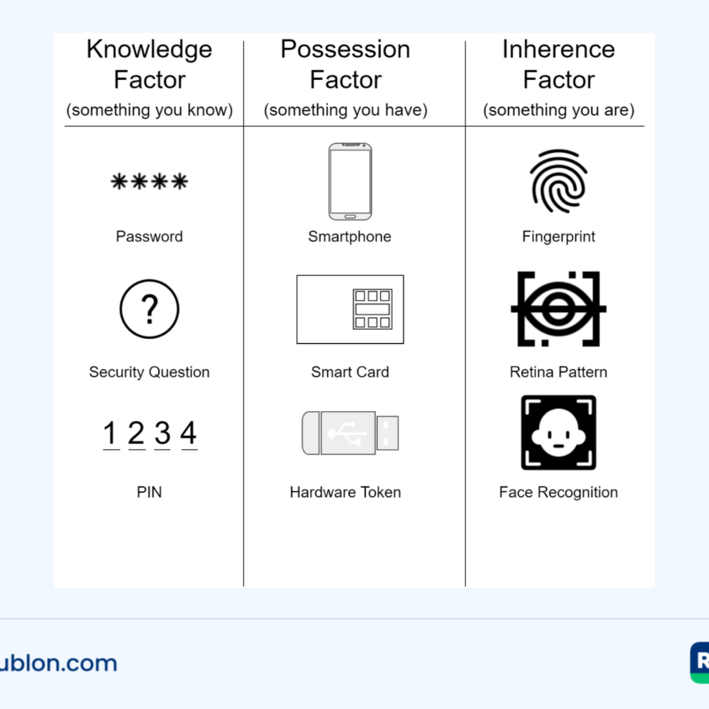

2. Types of Authentication System and System Authentication.
🔐 1. Types of Authentication Systems (the overall setup / methods used)
These are the ways a system is designed to authenticate users:
1. Password-Based System
- Username + password
- Most common
2. Multi-Factor Authentication (MFA) System
- Uses 2 or more methods together
- Example: password + OTP
3. Biometric Authentication System
- Based on physical traits
- Fingerprint, face, iris
4. Token-Based Authentication System
- Uses tokens instead of passwords after login
- Example: JWT tokens
5. OAuth / SSO Authentication System
- Login using another service
- Example: “Login with Google”
6. Certificate-Based Authentication System
- Uses digital certificates (mostly in enterprises)

🔑 2. Types of System Authentication (the actual process happening)
These are the types of verification used during authentication:
1. Knowled0067e-Based Authentication
- Something you know
- Example: password, PIN
2. Possession-Based Authentication
- Something you have
- Example: OTP on phone, smart card
3. Inherence-Based Authentication
- Something you are
- Example: fingerprint, face
4. Location-Based Authentication
- Based on where you are
- Example: login allowed only from certain country/IP
5. Behavior-Based Authentication
- Based on user behavior
- Typing speed, mouse movement

